**SONGBOOK DATABASE:**

**DATA FOR SONGS:**

**SYNTAX:** SELECT * from songs;

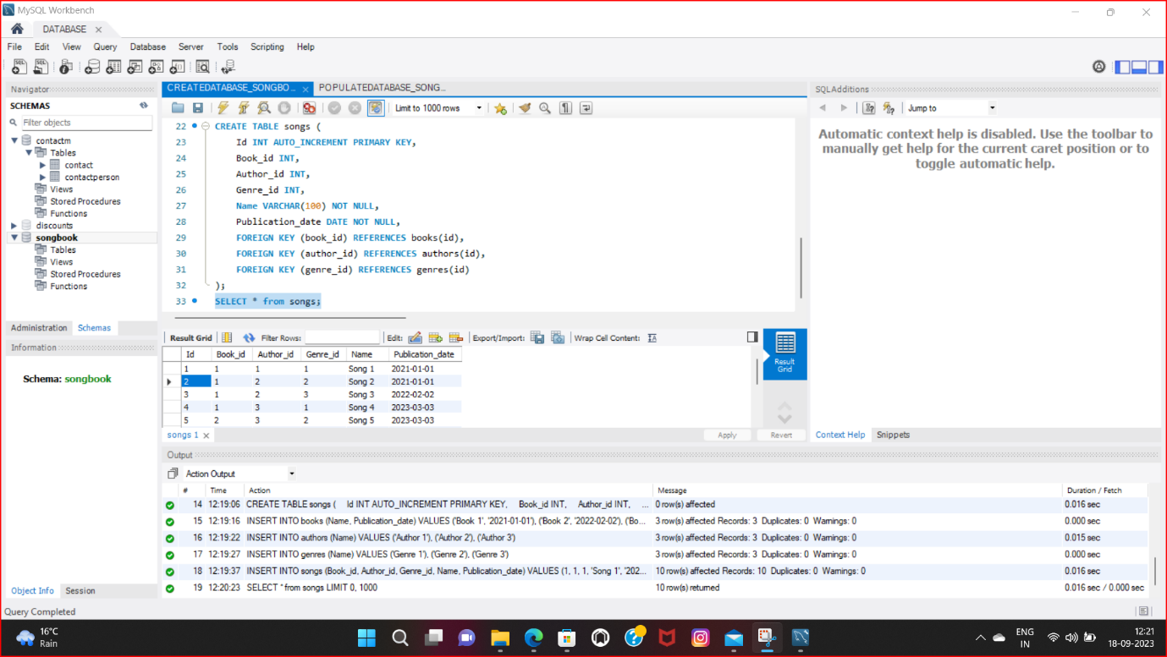

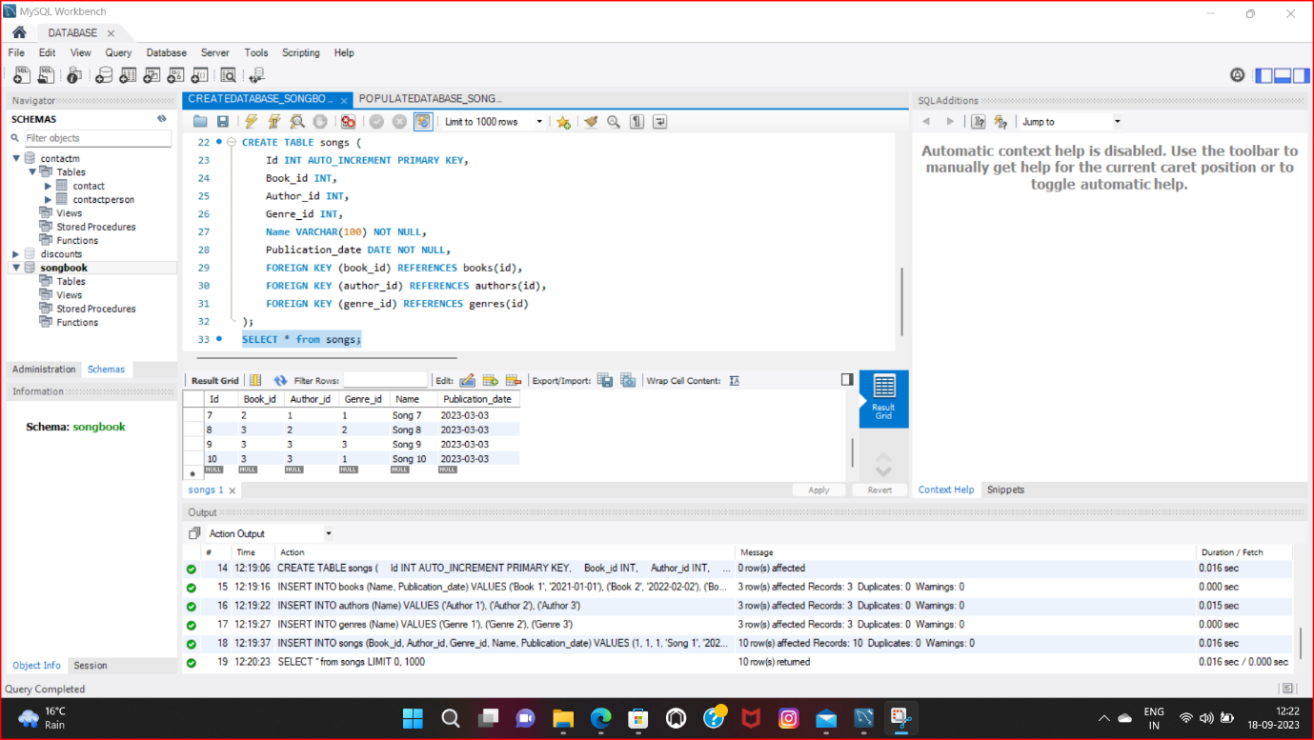

**DATA FOR BOOKS:**

**SYNTAX:** SELECT * from books;

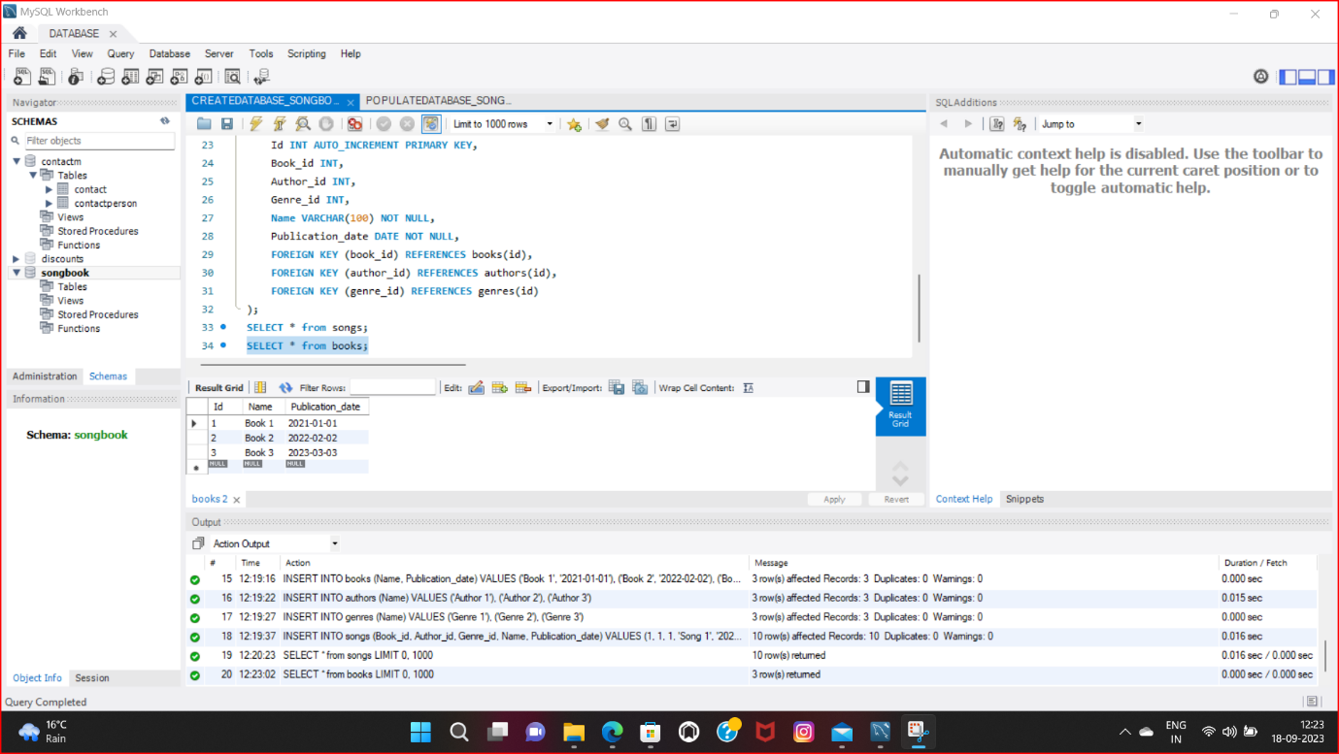

**DATA FOR AUTHORS:**

**SYNTAX**: SELECT * from authors;

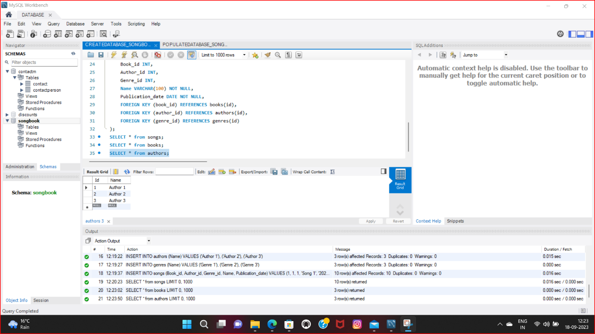

**DATA FOR GENRE:**

**SYNTAX**: SELECT * from genre;

